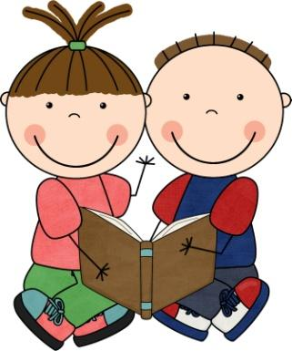
Stockbridge School Library
Pre-School Storytime
(During the school year and summer
Call Stockbridge School to find out the times
(920-439-1158)
Stockbridge School Website
https://sites.google.com/a/stockbridge.k12.wi.us/www/
If you have children ages 1-5 and are looking for something to do, join us once a week for Pre-School Storytime. Each week a different theme is introduced to the children through storytelling, crafts, interactive flannel boards, movement, and music. The program is free for all families in our community and surrounding area. The only requirement is an adult comes along for the fun!
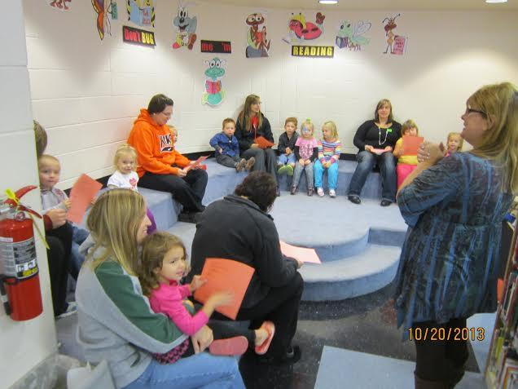
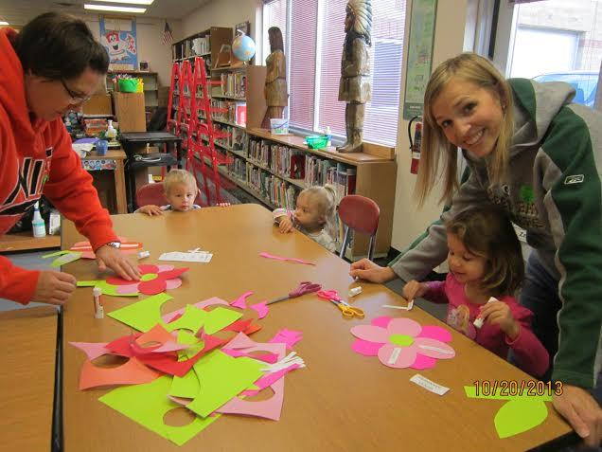
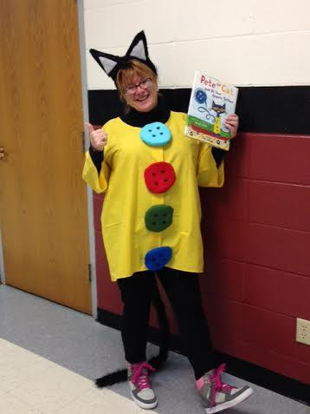

Winner of the:
“2014 Standing Up For Rural Wisconsin Schools, Libraries and Communities Award”
“I love the ability to interact with other parents in the community that have children the same age as my girls. Both of my girls look forward every week to time in the library, listening to stories and checking out books.”
–Tracy Hanke, mother of Kylie and Kayla
“Stockbridge Storytime makes a child’s first library experience local, positive, and rewarding.”
-David Moscinski, District Administrator, Stockbridge Schools

